



Implementation of Python Standard Library Modules with different operations
LAB MANUAL

Disclaimer: The content is curated from online/offline resources and used for educational purpose only
Implementation of Python Standard Library Modules with different operations

Objective:
- To explore the built-in modules that come with Python and how they provide tools for common tasks.
- To Learn how to use specific standard library modules such as math, random, datetime, os, and sys.

Problem Statement:
The Python Standard Library offers a wide variety of modules that provide powerful tools for handling common tasks, such as mathematical calculations, file handling, date and time manipulations, working with random numbers, and more. In this task, you will explore the usage of some essential Python Standard Library modules and implement them to perform different operation

Equipment Required:
- Install VS Code - https://code.visualstudio.com/download
- Download Python Installer File - https://www.python.org/downloads/
Prerequisites:
- Basic Computer Skills - Anyone starting to learn computer programming needs basic computer skills.
- Basics of control statements

Procedure:
Task 1: Implementation of math Module
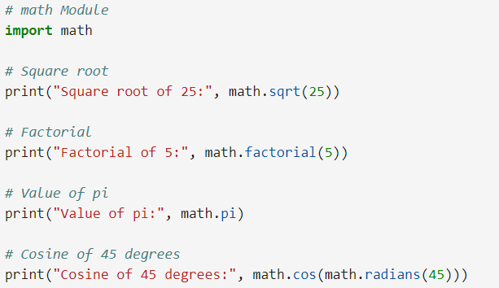
Output:
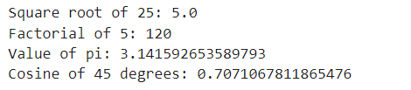

Task 2: Implementation of datetime Module
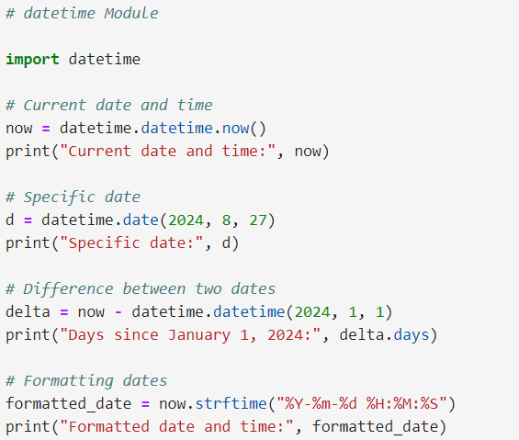

Output:
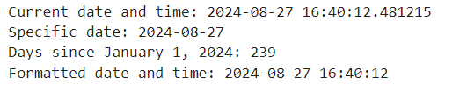

Task 3: Implementation of os Module
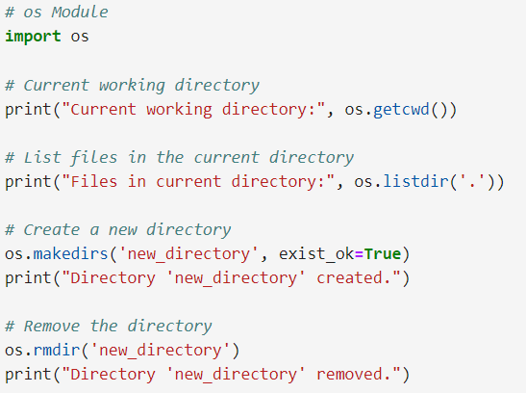
Output:
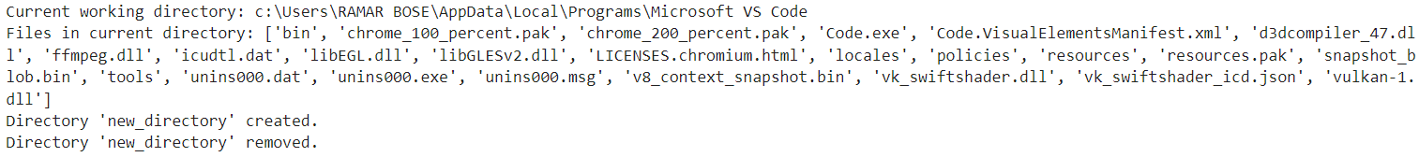

Task 4: Implementation of os sys Module
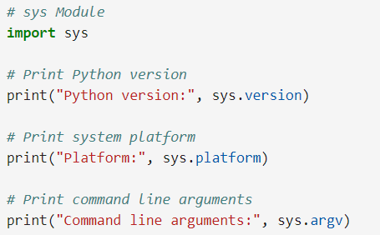
Output:
Task 5: Implementation of os random Module
